OBSERVATION1:

Whenever clicked on any logo/text in footer it is redirecting to login page.

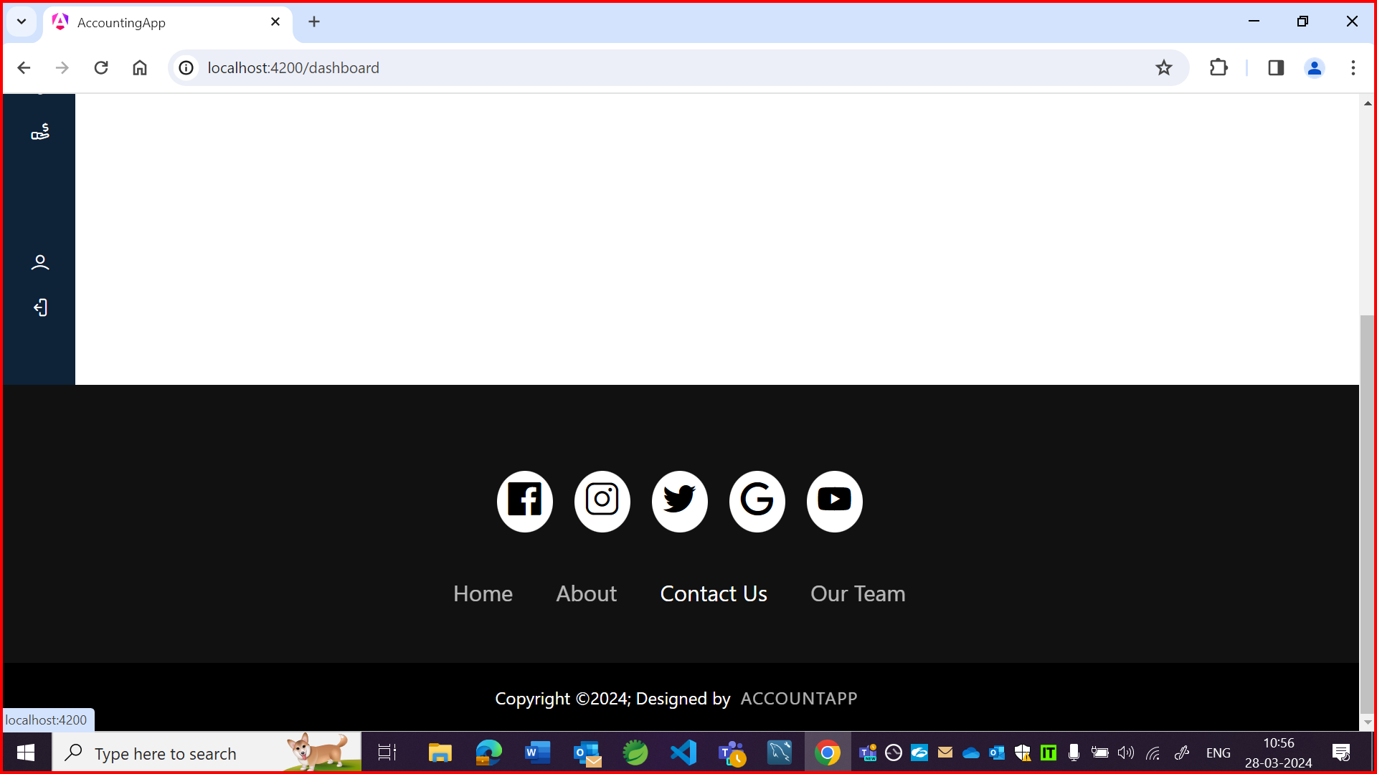

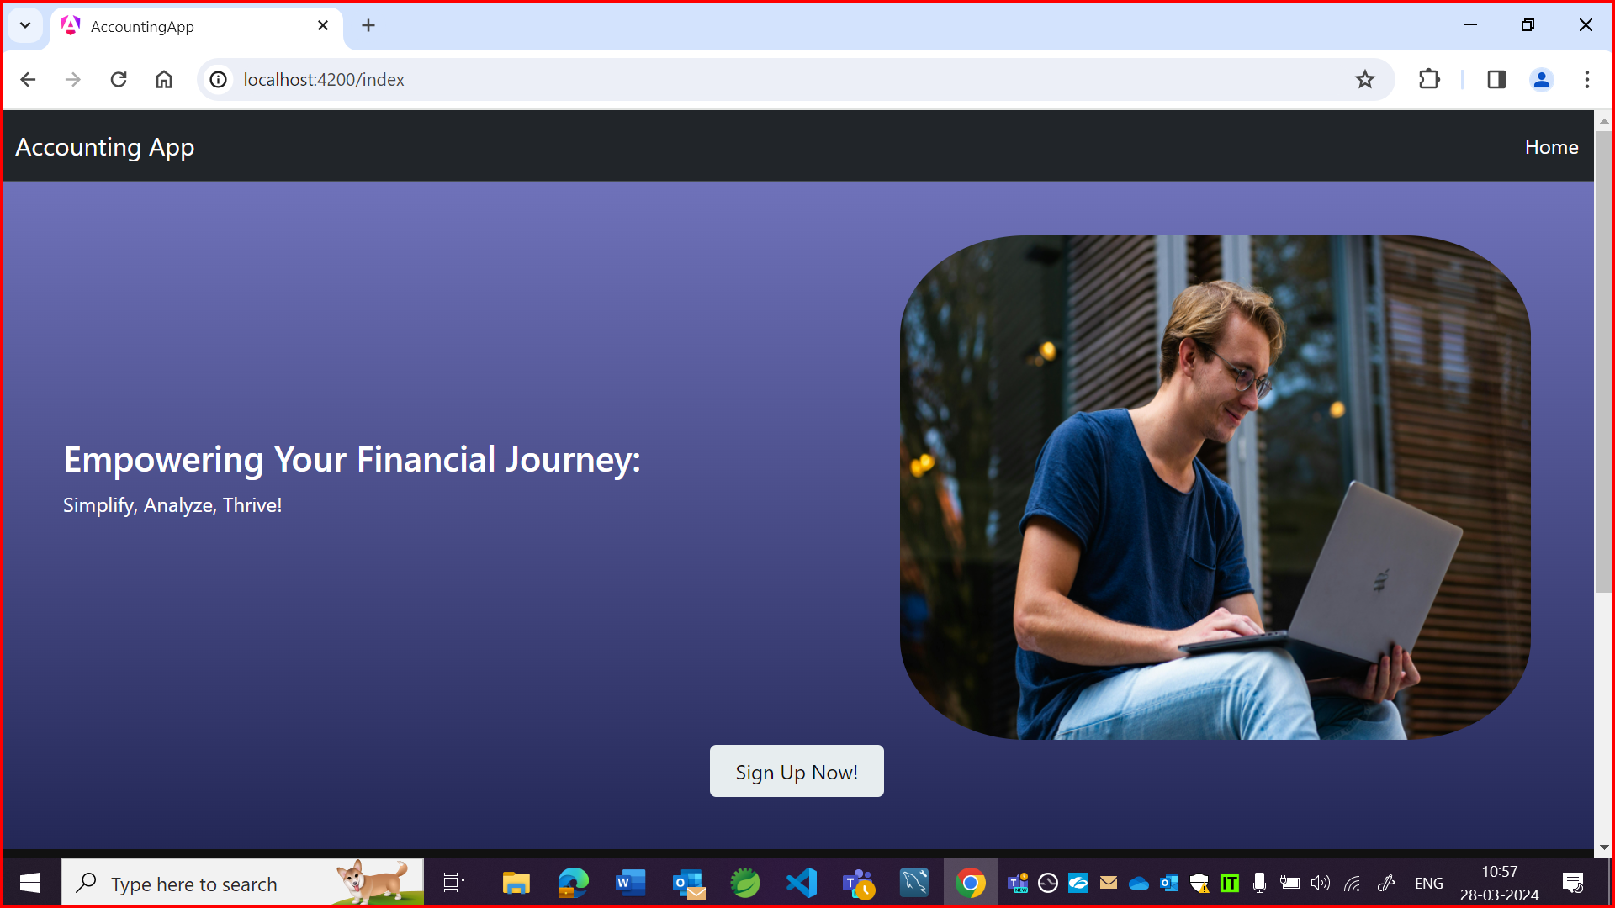

OBSERVATION2:

It is accepting future date.

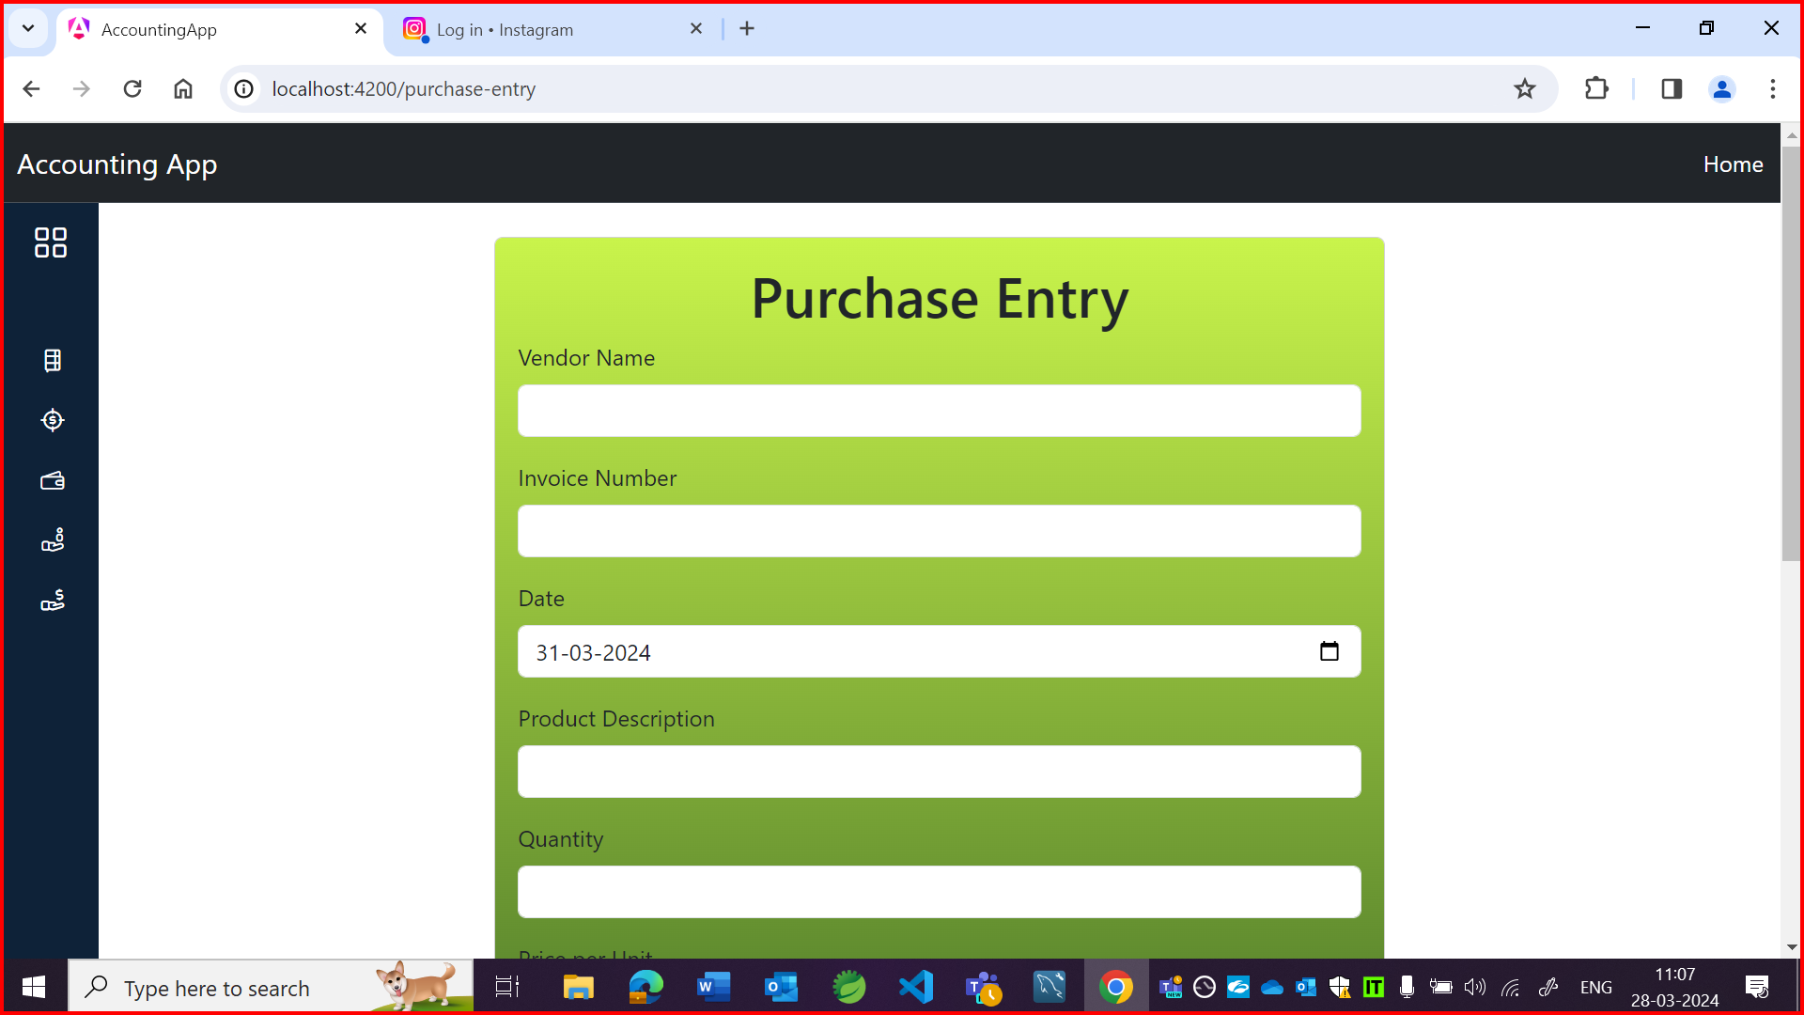

OBSERVATION3:

Whenever maximising any field, all fields are maximising.

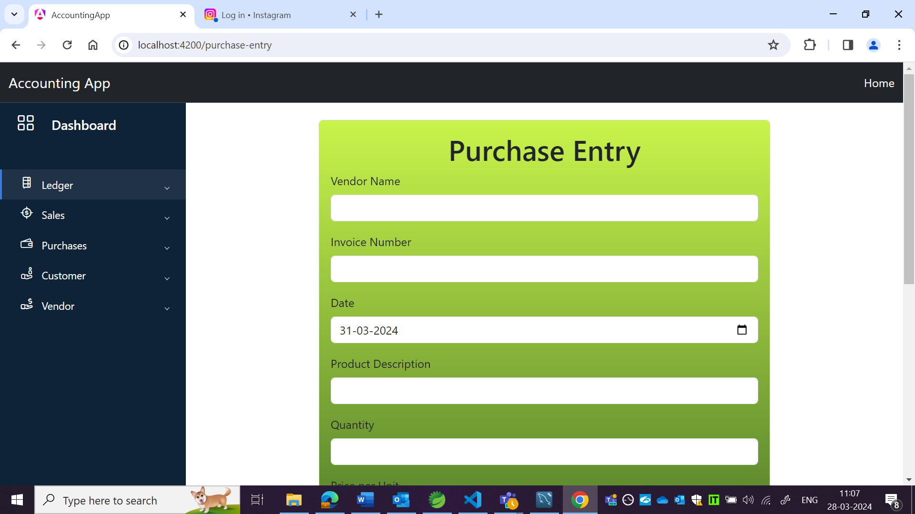

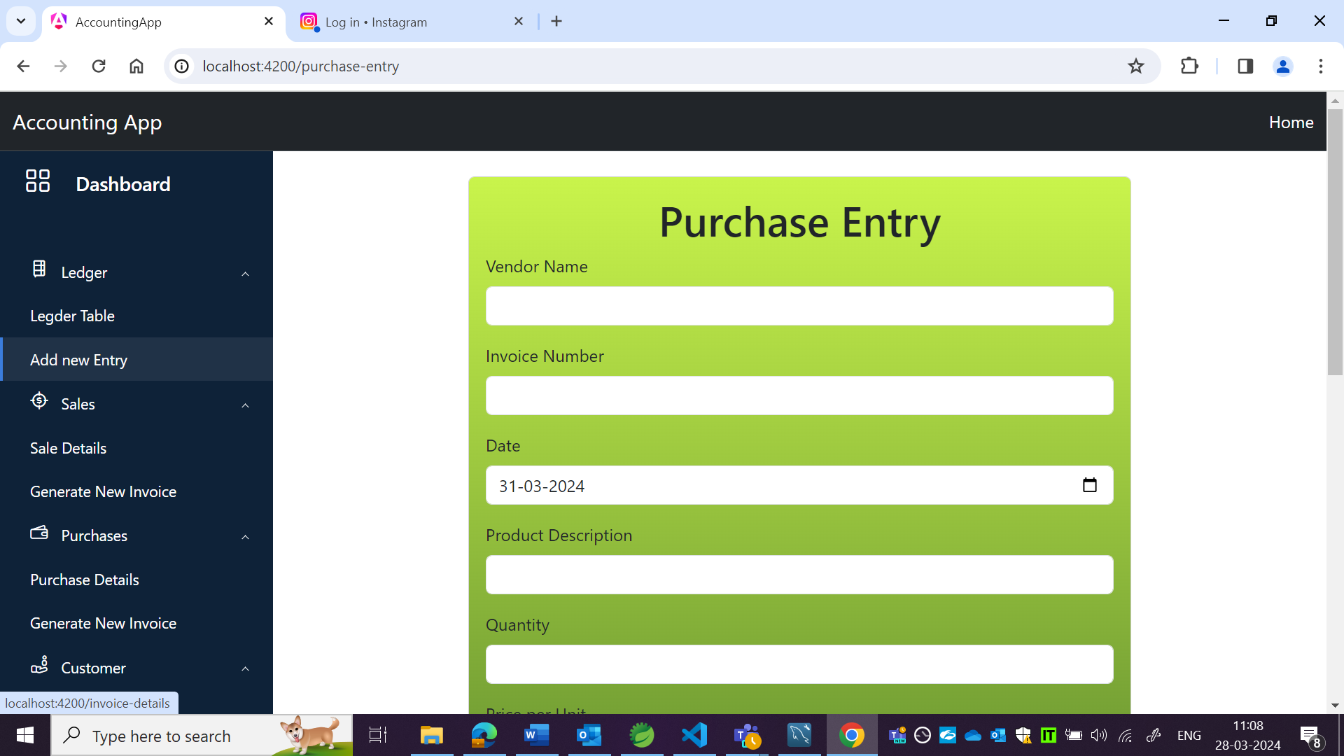

OBSERVATION4:

Sort and filter option is not available for vendor name, invoice no and status field but it should be there as per wireframe.

APP:

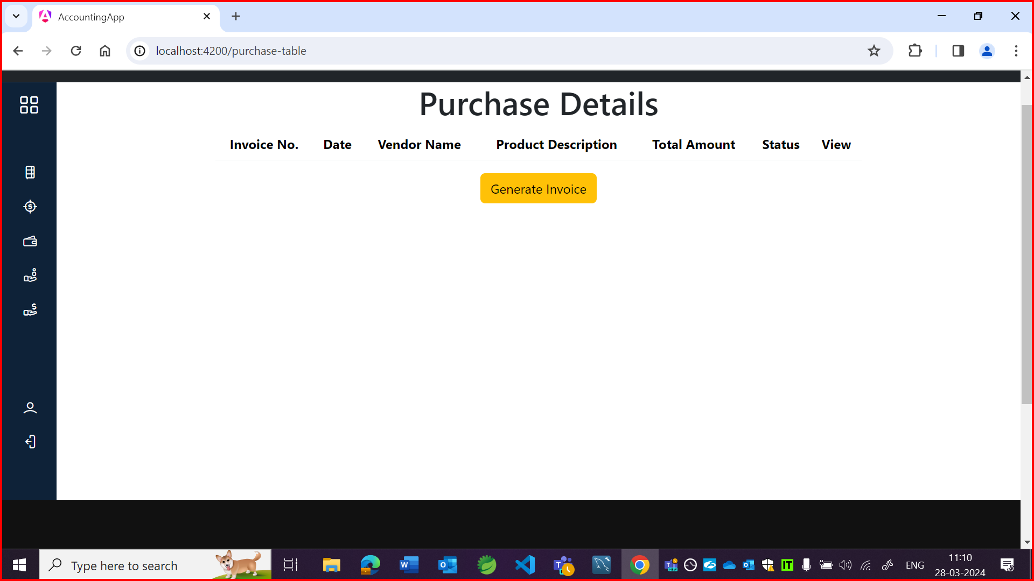

Wireframe:

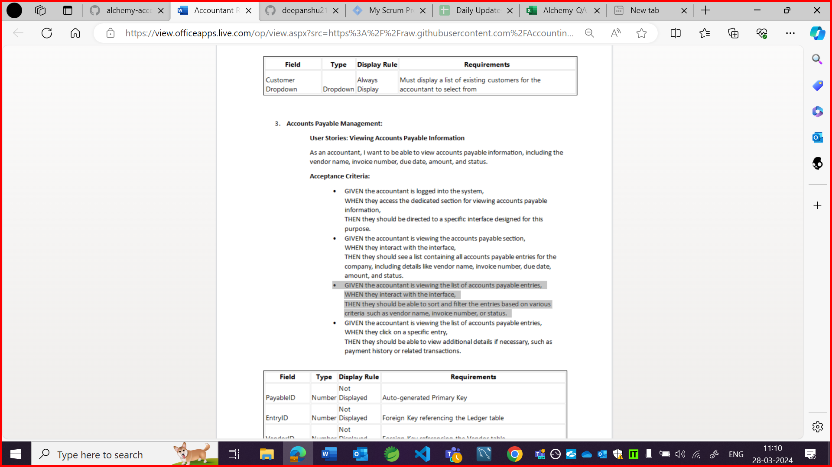

OBSERVATION5:

Field name should be due date and amount as per US.

App:

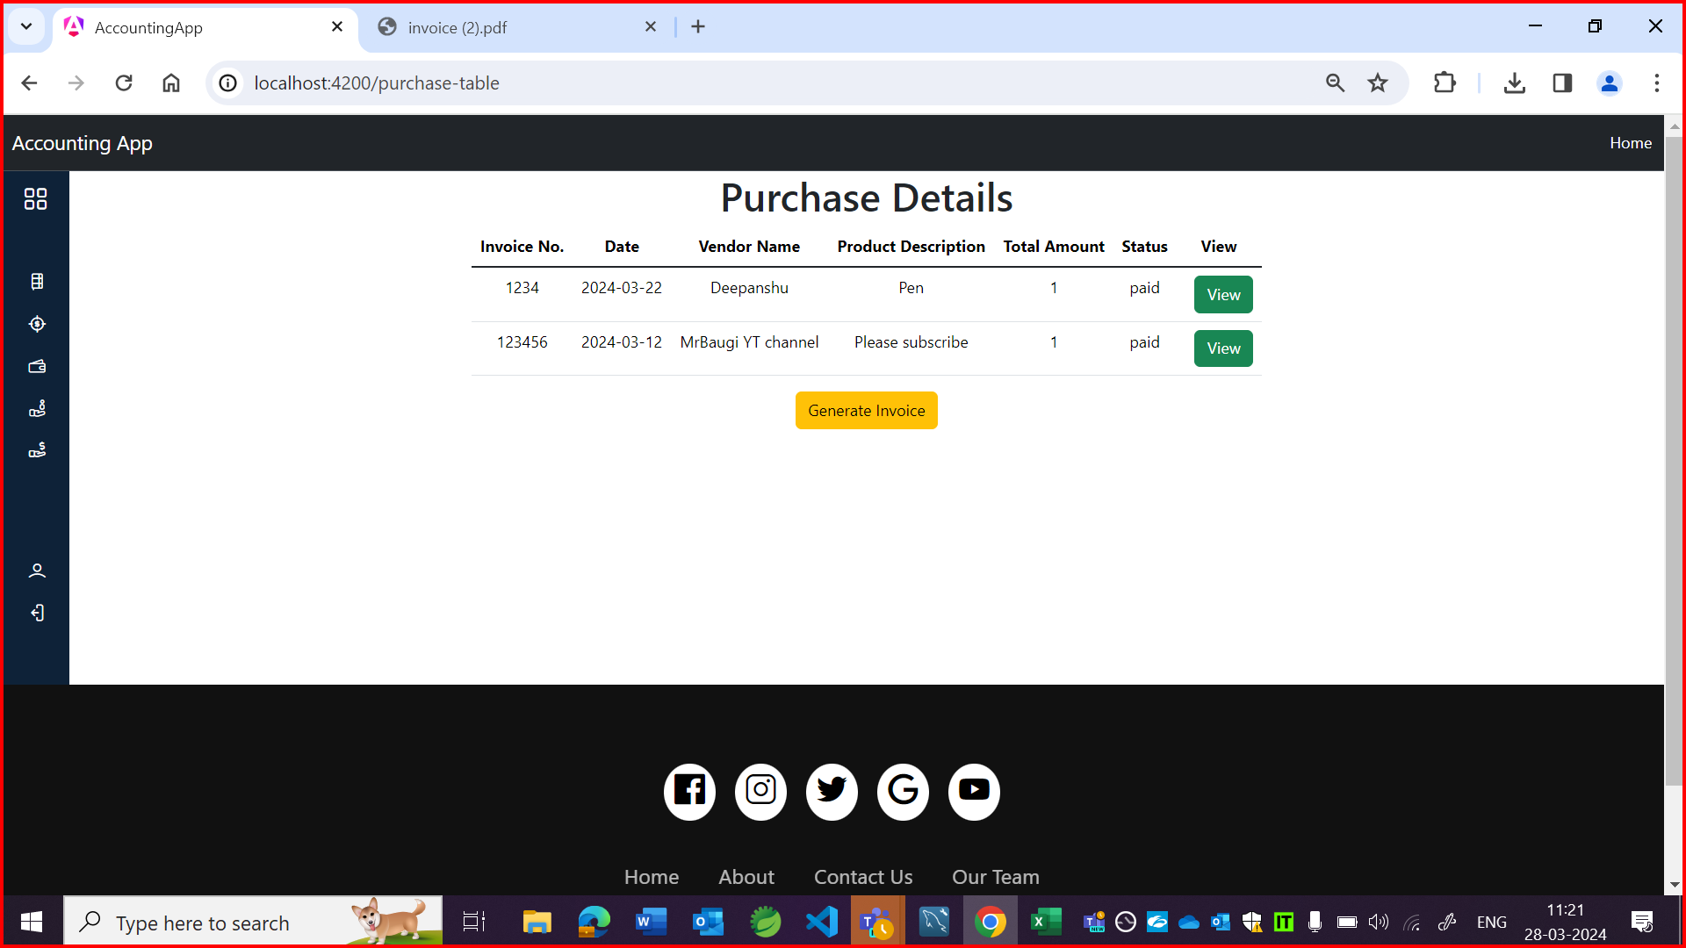



US:

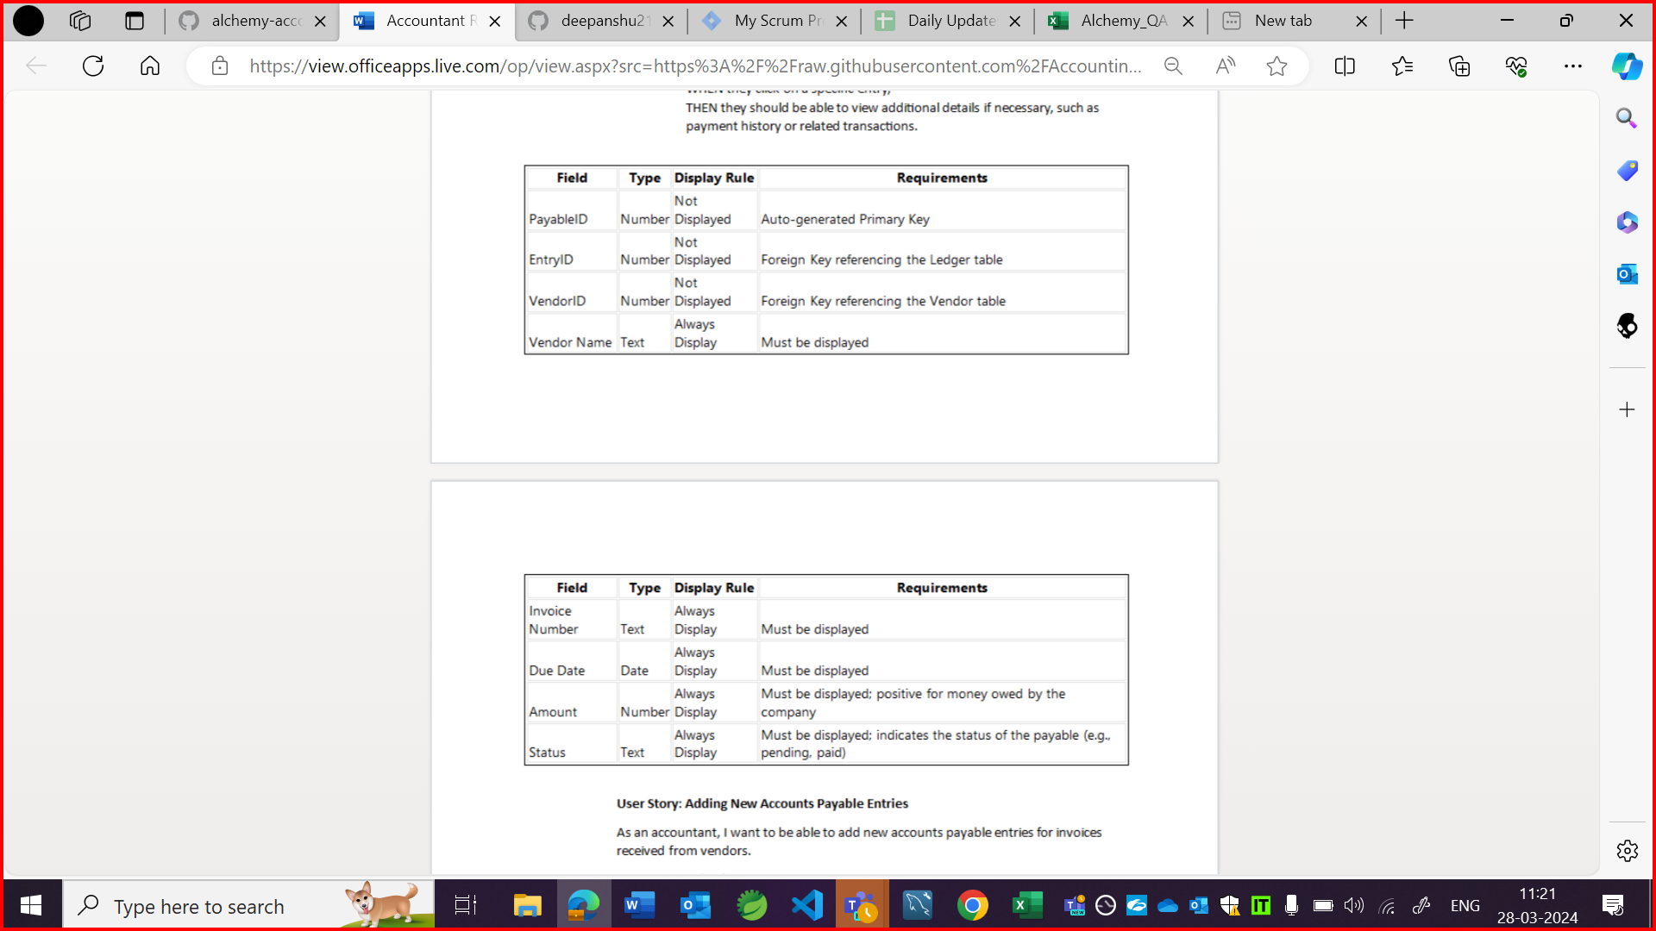

OBSERVATION6:

Detail should be in tabular format.



OBSERVATION7:

Vendor dropdown field should be there as per US.

App:

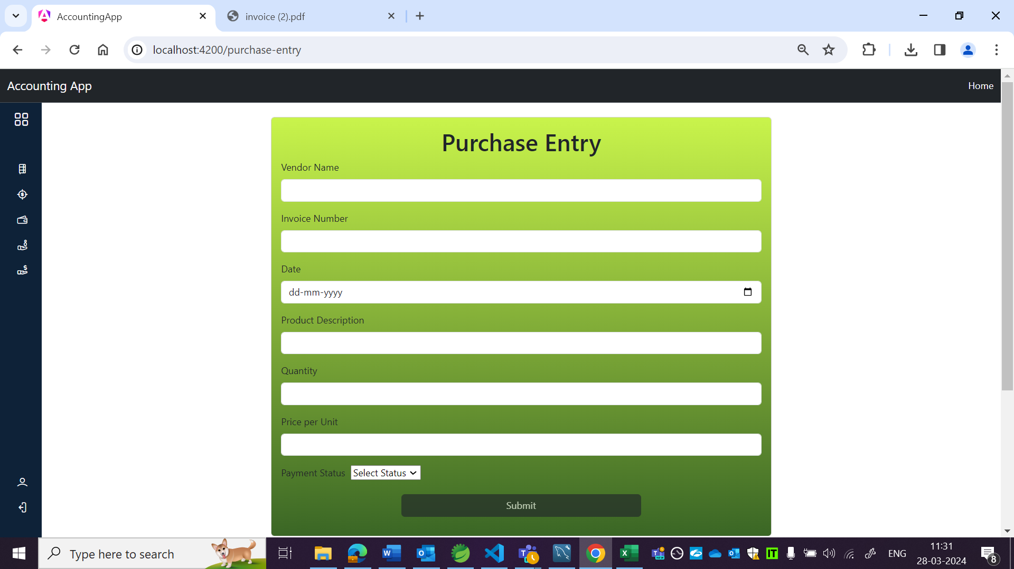

US:

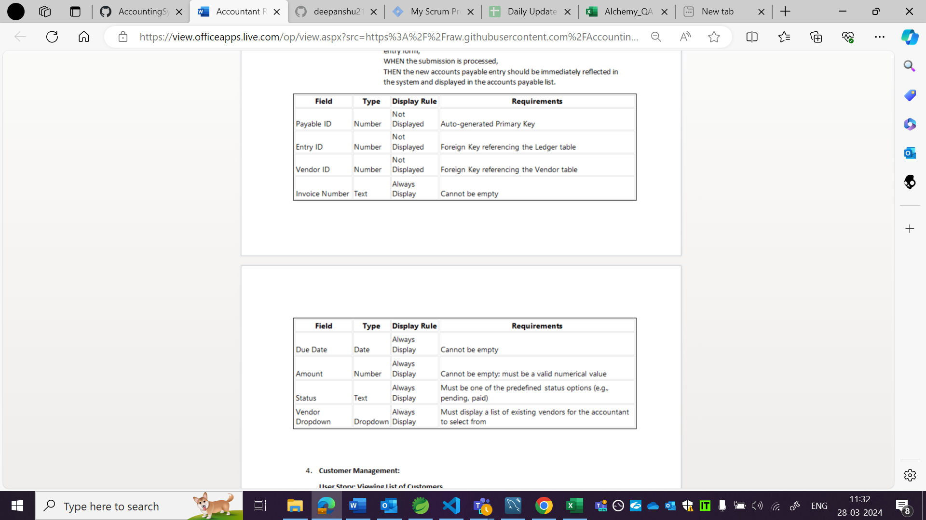

OBSERVATION8

Few fields in 1st row are not in 1 line.

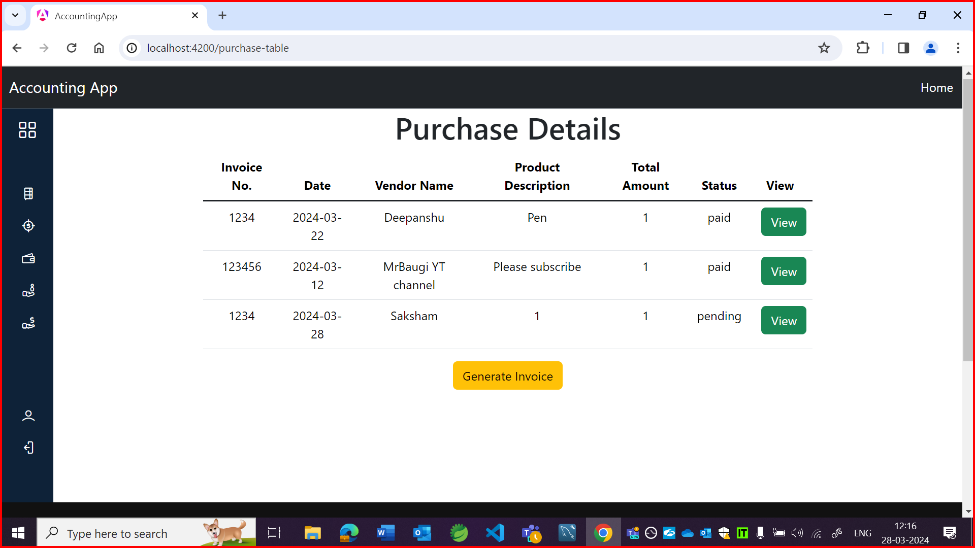

OBSERVATION9:

It is accepting same invoice number for 2 invoices.

